**Protein:** **YNL245C**

**IUPred2A:**

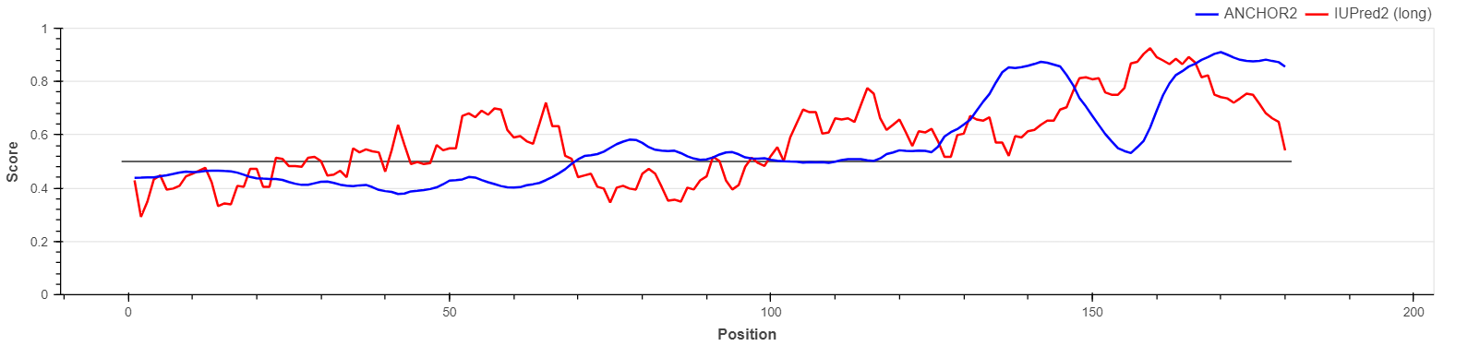

**Function:**

Involved in pre-mRNA splicing.

**Structure:**

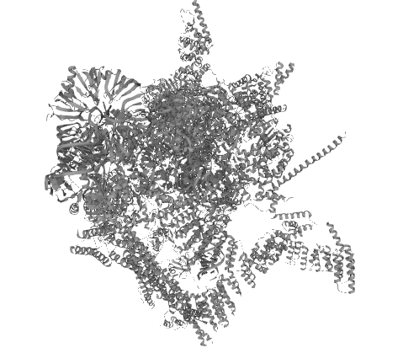

**Subcellular Location:** Nucleus

**Naša procjena: IDP**

**Protein:** **YDL201W**

**IUPred2A:**

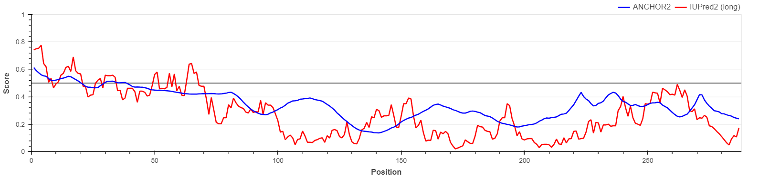

**Function:**

Methyltransferase that catalyzes the formation of N7-methylguanine at position 46 (m7G46) in tRNA, a modification required to maintain stability of tRNAs; its absence resulting in tRNA decay. Both the D-stem and T-stem structures of tRNAs are required for efficient methyltransferase activity.

**Structure:**

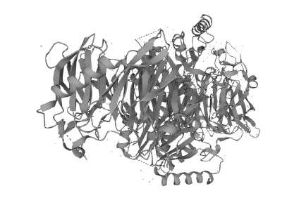

**Subcellular Location:** Nucleus

**Naša procjena: IDP**

**Protein:** **YDR424C**

**IUPred2A:**

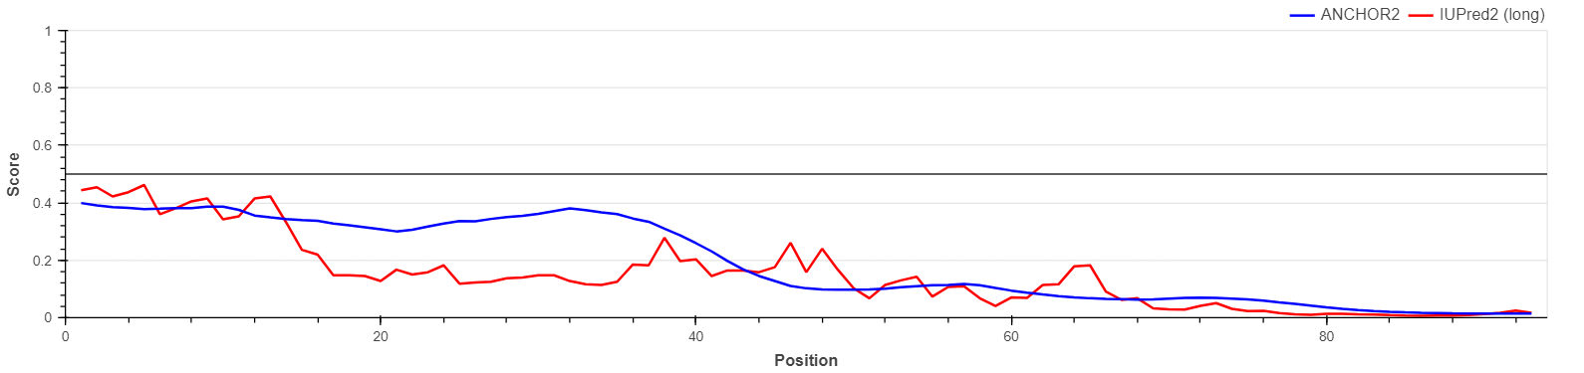

**Function:** Acts as one of several non-catalytic accessory components of the cytoplasmic dynein complex that are thought to be involved in linking dynein to cargos and to adapter proteins that regulate dynein function. Cytoplasmic dynein 1 acts as a motor for the intracellular retrograde motility of vesicles and organelles along microtubules. May play a role in changing or maintaining the spatial distribution of cytoskeletal structures (By similarity).

Also a component of the nuclear pore complex where it may contribute to the stable association of the Nup82 subcomplex with the NP

**Structure:**

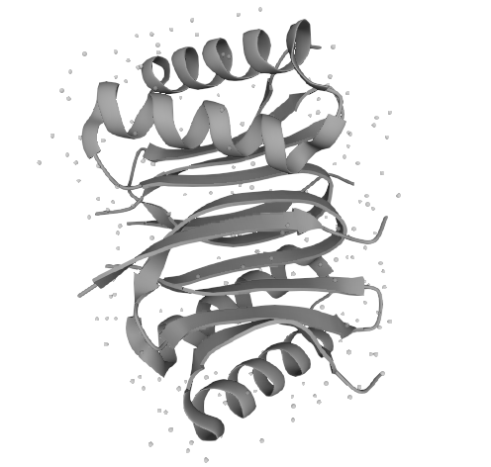

**Subcellular Location:** Cytoplasm, cytoskeleton Nucleus, nuclear pore complex

**Naša procjena: IDP**

**Protein:** **YKL103C**

**IUPred2A:**

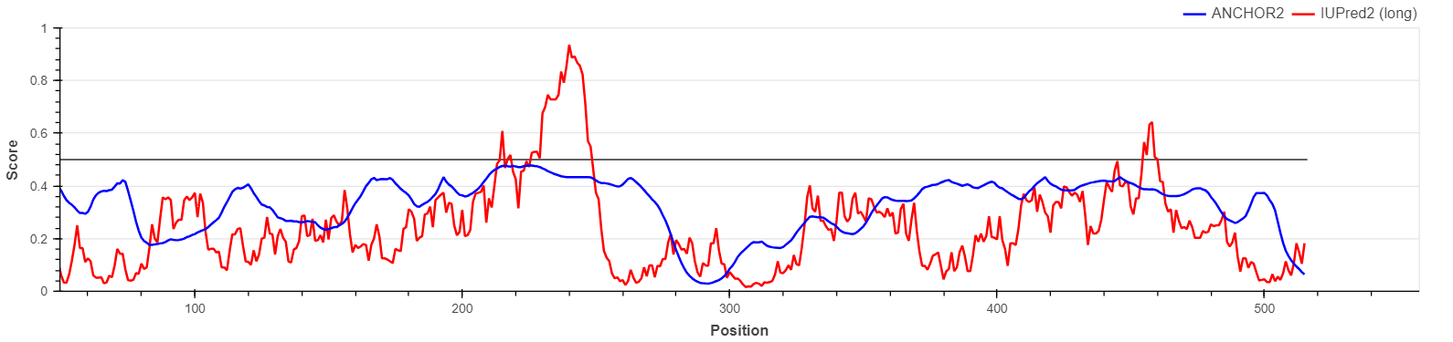

**Function:**

Resident vacuolar enzyme that catalyzes the removal of amino acids from the N-terminus of peptides and proteins. Also acts as the major cargo protein of the cytoplasm-to-vacuole targeting (Cvt) pathway. The precursor form of aminopeptidase 1 (prApe1) assembles into dodecamers and the propeptide mediates the aggregation of dodecamers into higher multimers. The multimers are then recognized via the propeptide by their receptor ATG19, and ATG19 further interacts with ATG11, which tethers the APE1-ATG19 complex to the pre-autophagosomal structure (PAS). The cargo-receptor complex (also Cvt complex) is selectively enwrapped by a double-membrane structure termed the Cvt vesicle under vegetative growth conditions and by a similar but larger double-membrane structure termed the autophagosome under nitrogen starvation conditions. The Cvt vesicle or the autophagosome fuses with the vacuolar membrane and release its content in the vacuolar lumen. In the vacuole, prApe1 is processed into mature aminopeptidase 1 (mApe1)

**Structure:**

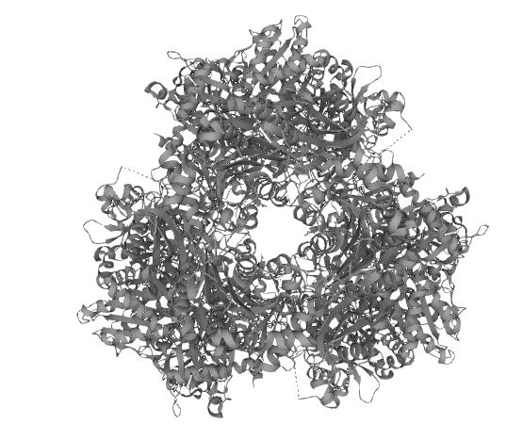

**Subcellular Location:** Vacuole

**Naša procjena: non-IDP**

**Protein:** **YFR011C**

**IUPred2A:**

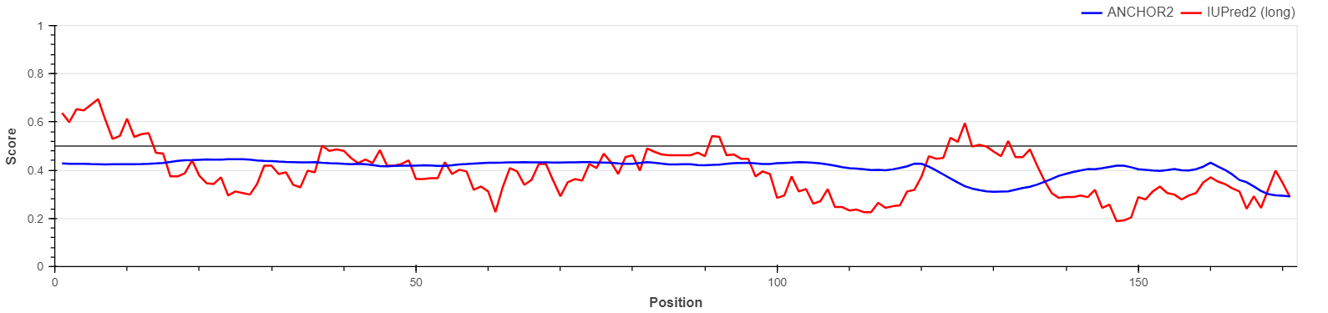

**Function:**

Component of the MICOS complex, a large protein complex of the mitochondrial inner membrane that plays crucial roles in the maintenance of crista junctions, inner membrane architecture, and formation of contact sites to the outer membrane

**Structure:**

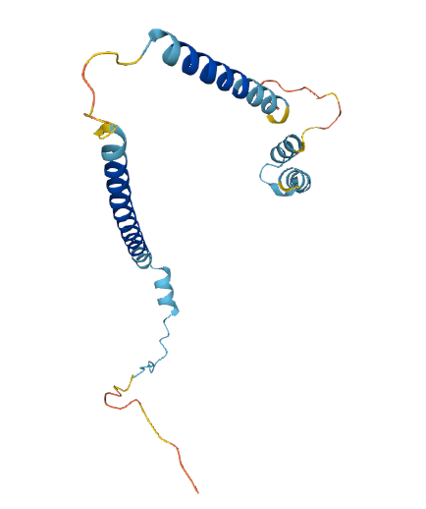

**Subcellular Location:** Mitochondrion inner membrane

**Naša procjena: non-IDP???**

**Protein:** **YKL172W**

**IUPred2A:**

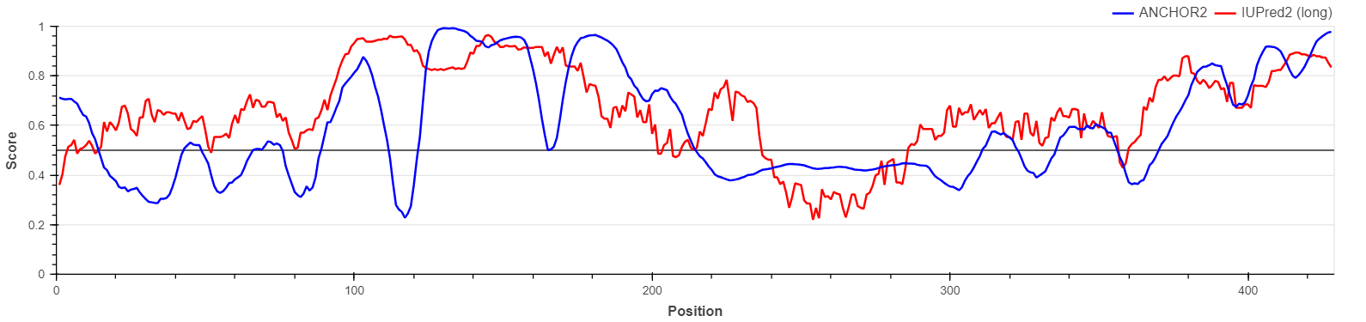

**Function:**

Required for the processing of the 27S pre-rRNA. Probably involved in the step of the processing of the 27 SA precursor into the 27 SB intermediate

**Structure:**

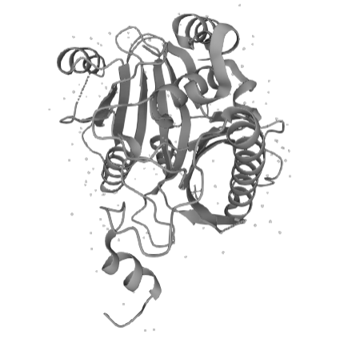

**Subcellular Location:** Nucleus, nucleolus

**Naša procjena: IDP**